LOCK HUB

Date:08.08.2024
- Engaged condition: The lock engages the drive system, allowing the drive wheel rotation to be transmitted through the bevel & pinion gear to the impeller, so the impeller rotates and fertilizer spreading takes place.

- Disengaged condition: The drive transmission is disconnected, so the impeller remains free from the drive-wheel rotation.

- When the fertilizer spreader is not spreading, the lock should remain disengaged, allowing the tractor/spreader wheels to rotate freely without driving the impeller.

- The purpose of disengagement is also to protect the bevel & pinion gears from excessive rotational speed. If the spreader is operated above approximately 6 km/h, the drive-wheel speed increases and can cause excessive RPM/load on the bevel and pinion gears, potentially resulting in gear damage.

Simple working sequence
Drive wheel → Lock → Bevel gear → Pinion gear → Impeller
Engaged:
Drive→ Lock ENGAGED → Gear transmission → Impeller rotates → Spreading ON
Disengaged:
Coast → Lock DISENGAGED → Drive disconnected → Impeller free → Spreading OFF
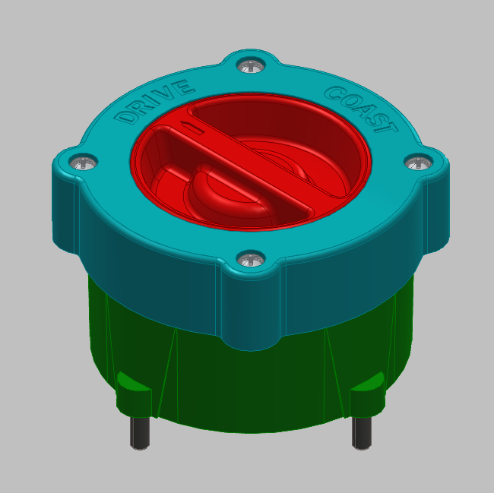 | 